

**COMPUTER ENGINEERING**

**CG ODD SEM 2021-22/EXPERIMENT 6 NAME:- GAURAV AMARNANI (D7A, 67)**

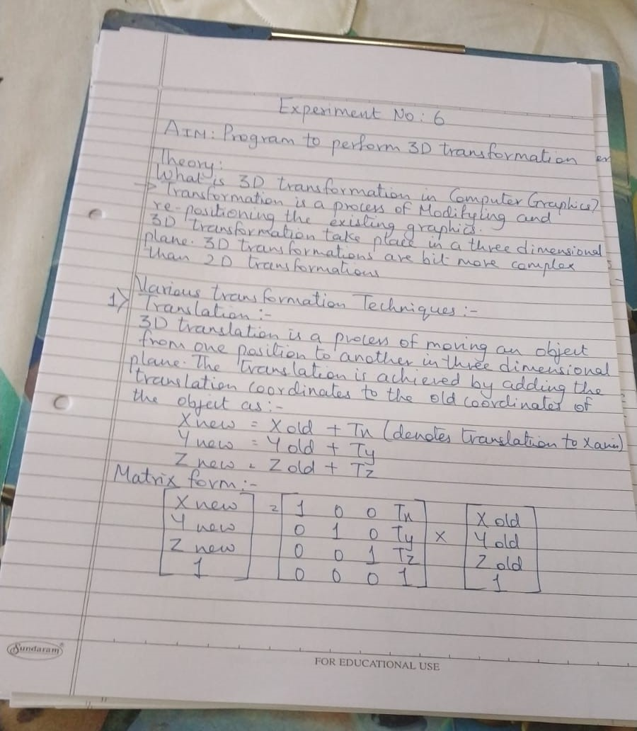

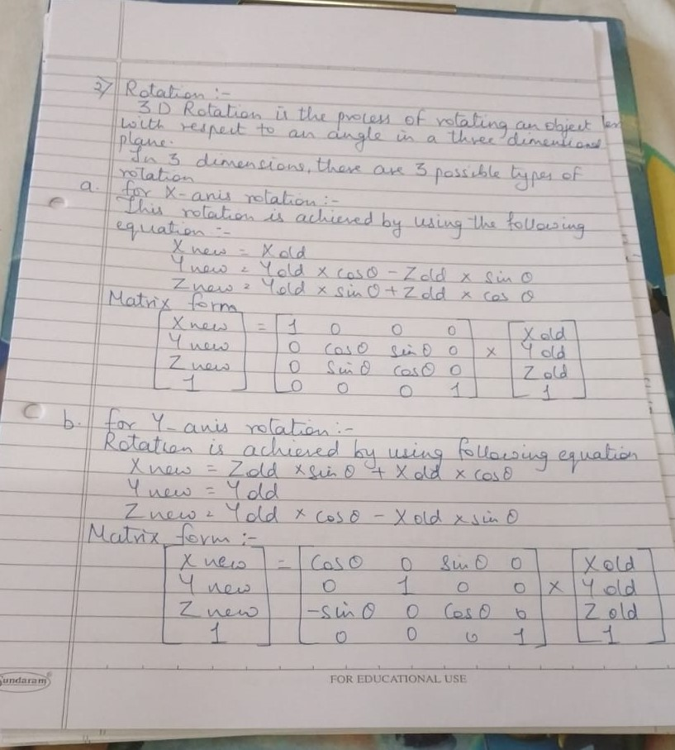

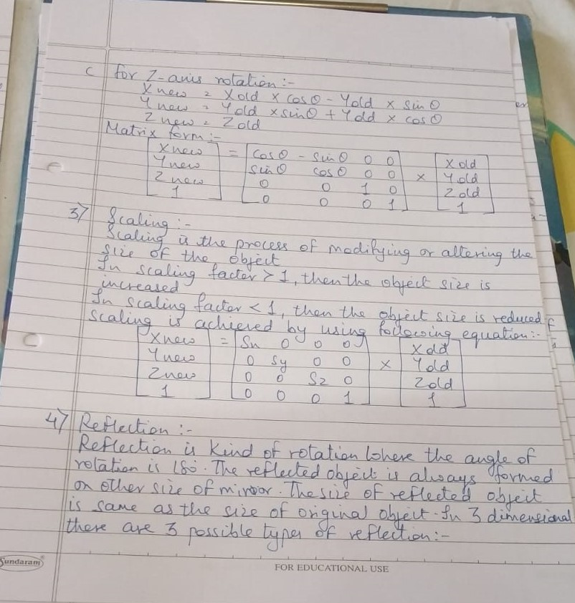

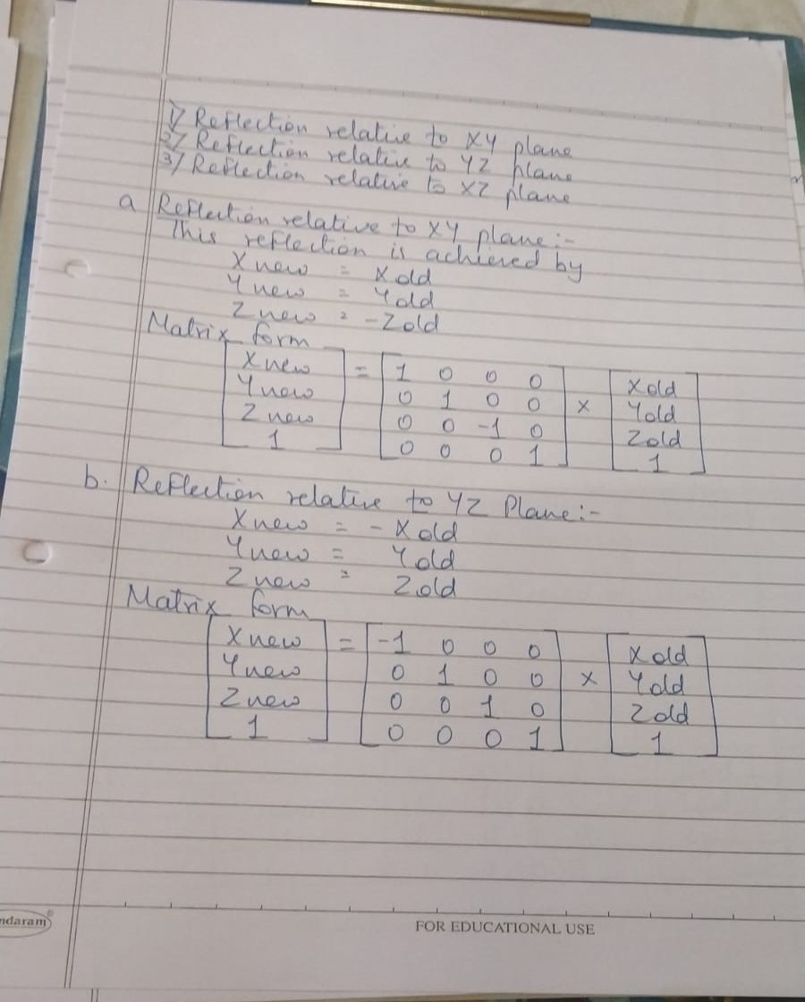

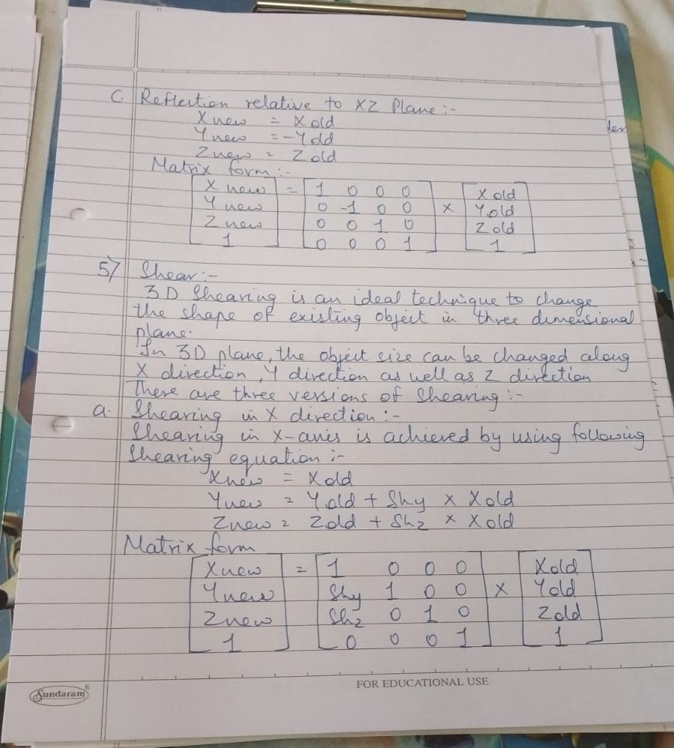

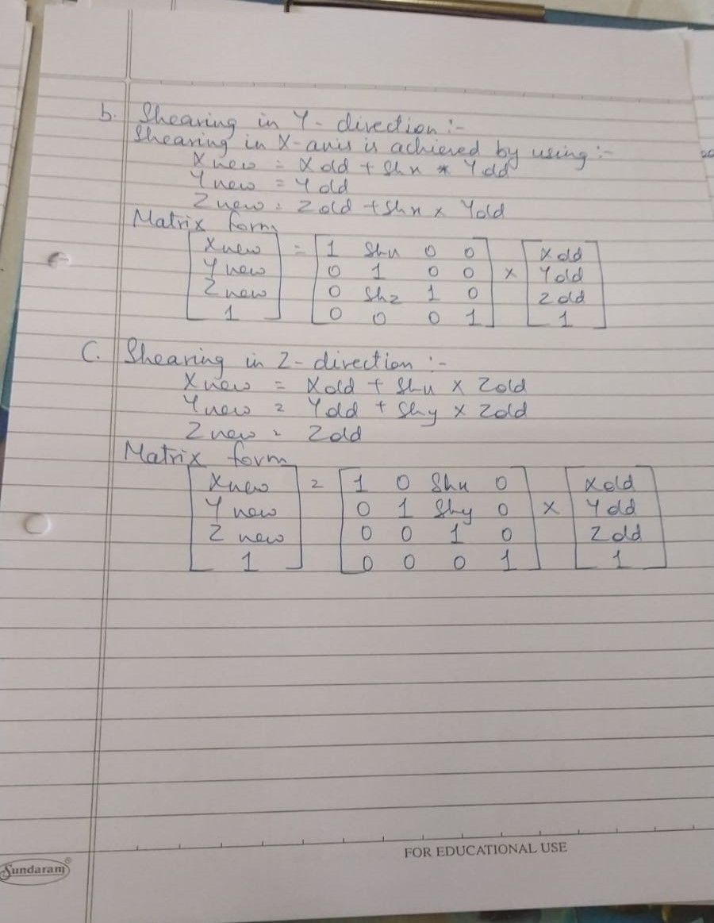

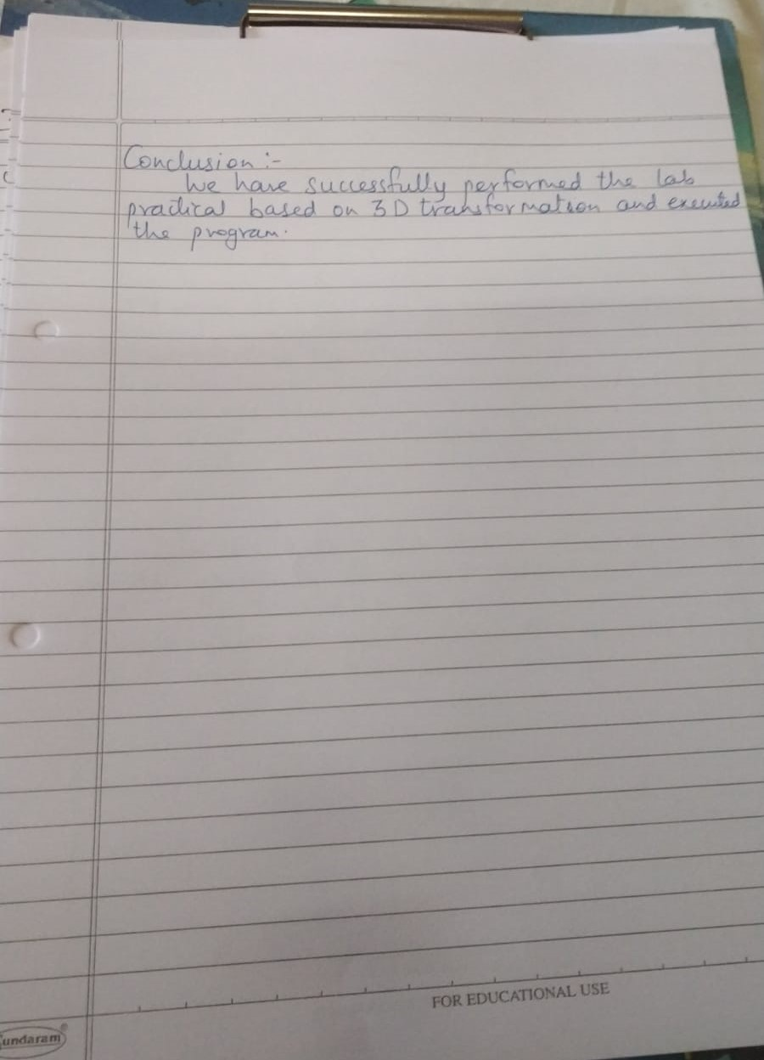

Program:

#include<stdio.h>

#include<conio.h>

#include<graphics.h>

#include<math.h>

int maxx,maxy,midx,midy;

void axis() {

getch();

cleardevice();

line(midx,0,midx,maxy);

line(0,midy,maxx,midy);

}

void main() {

int gd,gm,x,y,z,ang,x1,x2,y1,y2;

detectgraph(&gd,&gm);

initgraph(&gd,&gm,"C:/TC/BGI");

setfillstyle(3,25);

maxx=getmaxx();

maxy=getmaxy();

midx=maxx/2;

midy=maxy/2;

outtextxy(100,100,"ORIGINAL OBJECT");

line(midx,0,midx,maxy);

line(0,midy,maxx,midy);

bar3d(midx+100,midy-20,midx+60,midy-90,20,5);

axis();

outtextxy(100,20,"TRANSLATION");

printf("\n\n Enter the Translation vector: ");

scanf("%d%d",&x,&y);

bar3d(midx+100,midy-20,midx+60,midy-90,20,5);

bar3d(midx+(x+100),midy-(y+20),midx+(x+60),midy-(y+90),20,5);

axis();

outtextxy(100,20,"SCALING");

printf("\n Enter the Scaling Factor: ");

scanf("%d%d%d",&x,&y,&z);

bar3d(midx+100,midy-20,midx+60,midy-90,20,5);

bar3d(midx+(x*100),midy-(y*20),midx+(x*60),midy-(y*90),20*z,5);

axis();

outtextxy(100,20,"ROTATION");

printf("\n Enter the Rotation angle: ");

scanf("%d",&ang);

x1=100*cos(ang*3.14/180)-20*sin(ang*3.14/180);

y1=100*sin(ang*3.14/180)+20*sin(ang*3.14/180);

x2=60*cos(ang*3.14/180)-90*sin(ang*3.14/180);

y2=60*sin(ang*3.14/180)+90*sin(ang*3.14/180);

axis();

printf("\n After rotating about z-axis\n");

bar3d(midx+100,midy-20,midx+60,midy-90,20,5);

bar3d(midx+x1,midy-y1,midx+x2,midy-y2,20,5);

axis();

printf("\n After rotating about x-axis\n");

bar3d(midx+100,midy-20,midx+60,midy-90,20,5);

bar3d(midx+100,midy-x1,midx+60,midy-x2,20,5);

axis();

printf("\n After rotating about y-axis\n");

bar3d(midx+100,midy-20,midx+60,midy-90,20,5);

bar3d(midx+x1,midy-20,midx+x2,midy-90,20,5);

axis();

closegraph();

Output:

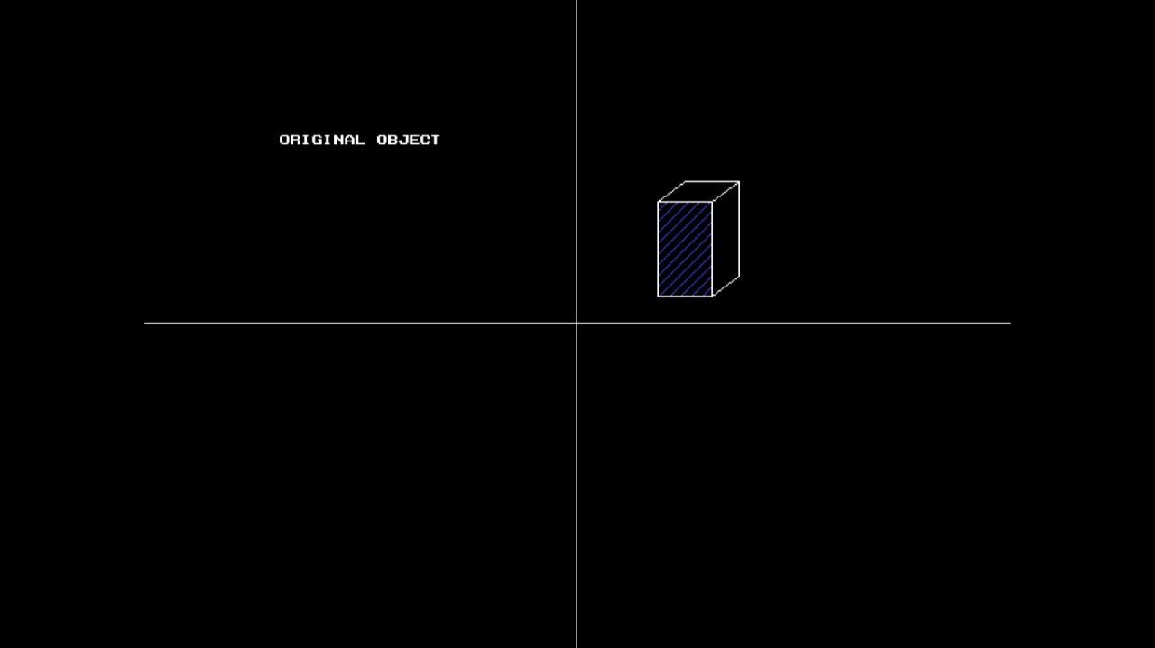

1. **TRANSLATION:-**

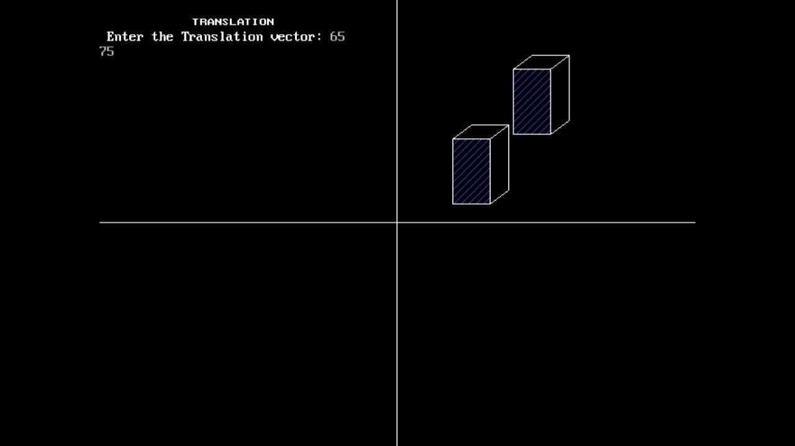

1. **SCALING:-**

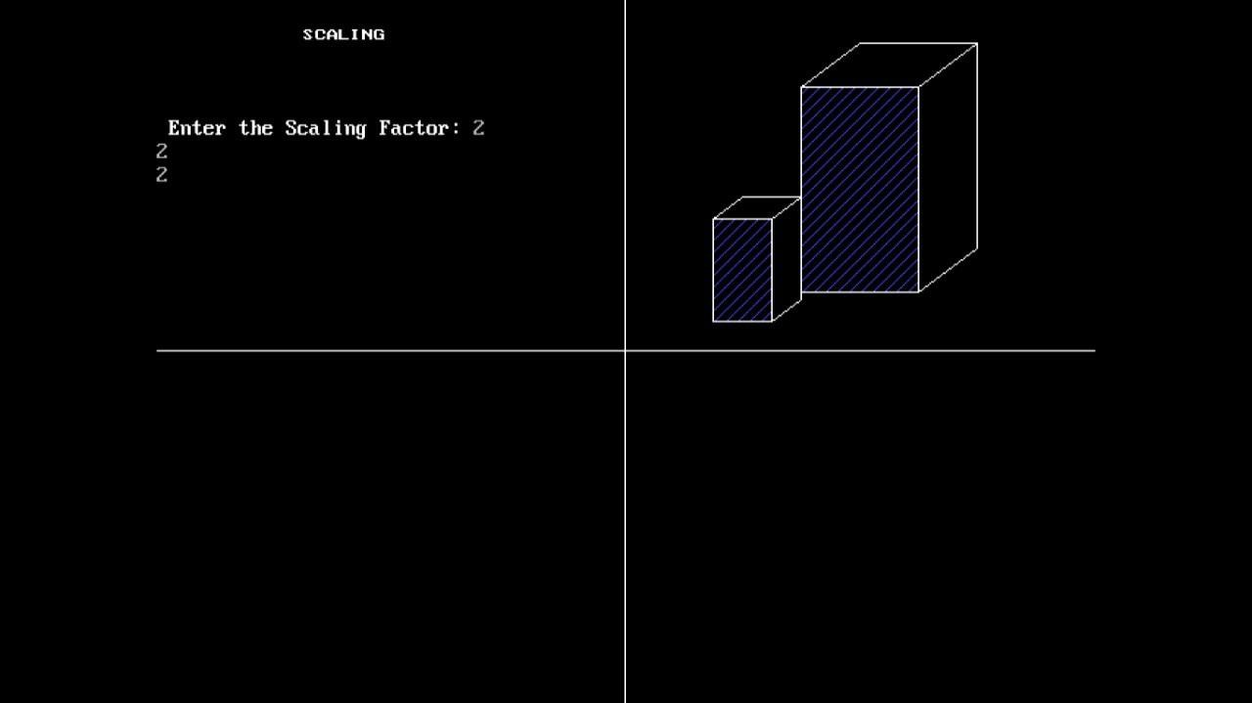

1. 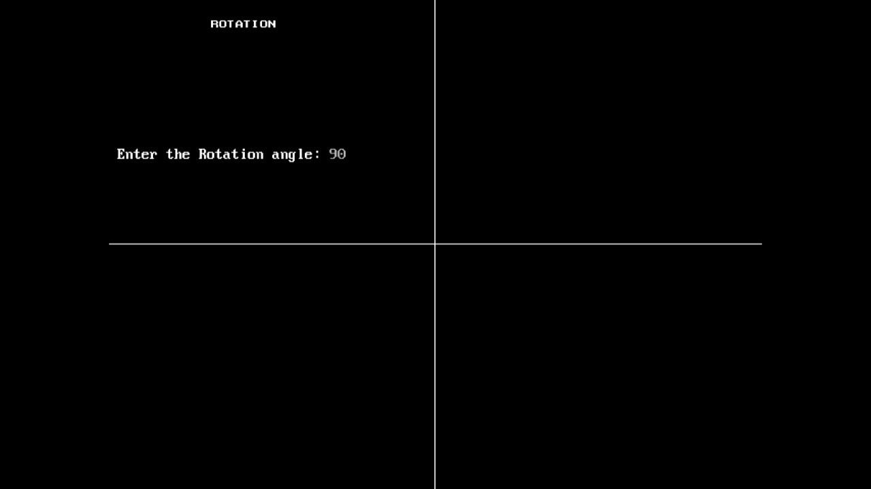**ROTATION:-**

